Calculating Beta Using Co-variance
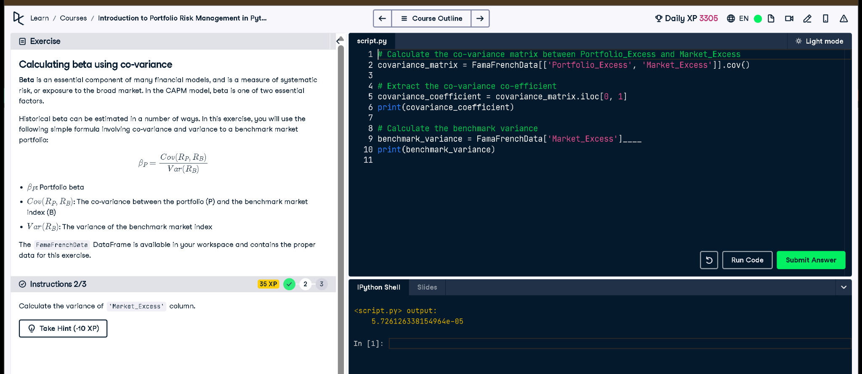

Python Code
# Calculate the co-variance matrix between Portfolio_Excess and Market_Excess
covariance_matrix = FamaFrenchData[['Portfolio_Excess', 'Market_Excess']].cov()
# Extract the co-variance co-efficient
covariance_coefficient = covariance_matrix.iloc[0, 1]
print(covariance_coefficient)
# Calculate the benchmark variance
benchmark_variance = FamaFrenchData['Market_Excess'].var()
print(benchmark_variance)

Explanation (in Simple Words)
This code calculates how much the portfolio and the market move together (covariance), then gets the market’s own movement range (variance). These two values are needed to compute the beta, which shows how risky the portfolio is compared to the market. Higher beta means more market-related risk.

